Trần Như Nguyện DH52007186 D20_TH10 (học thứ 5 ca2)

Bài 2 scanning

c. Các công nghệ web được dùng trên domain stu.edu.vn: Apache, Bootstrap, Cookies[_csrf-frontend], Email[contact@stu.edu.vn,student@stu.edu.vn], Frame, HTML5, HTTPServer[Apache], HttpOnly[_csrf-frontend], JQuery, Script, X-UA-Compatible[IE=edge], YouTube.

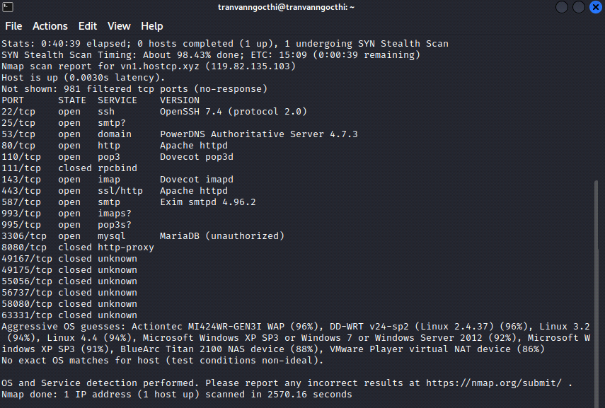

a. Scan port:

22, 25, 53, 80, 110, 111, 143, 443, 587, 993, 995, 3306, 8080, …

Dịch vụ: smtp, ssh, domain, http, pop3, rpcbind, imap, ssl/http, mysql, …

Scan OS:



OS cơ sở: linux_kernel v2.4.3

OS cụ thể: linux v2.4.37, linux 3.2